Exercise #02
Android Developer Bootcamp

Purpose

This Exercise defines a beautiful Student Profile UI using different Android layouts. The UI contains a profile section and a details card.

Problem

This Exercise create a card, student details like Age, Email, Department, Phone, and Location are displayed.The application is designed using LinearLayout, RelativeLayout.

How to Solve
1. Checkout the workshop from Git Repo:
git clone -b <user-branch> <repo-URL>
2. Open the root folder inside Android Studio.
3. To build the app click the run icon.
4. Create a Layouts, TextView .
5. Developer can choose it’s UI design.

Screenshots

Expected Output

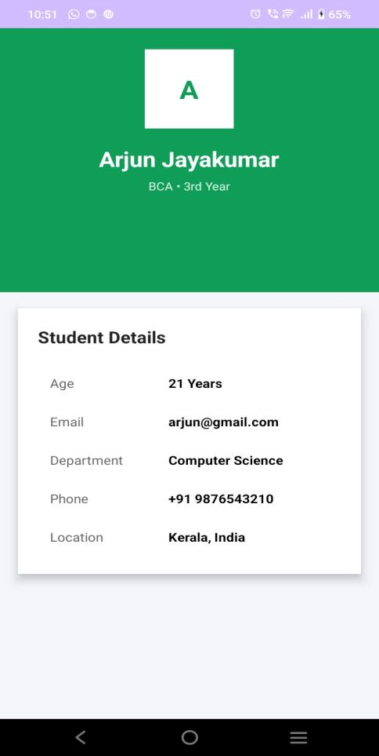

How to submit your Exercise
Push your project back to the same git branch using command:
<command name>

Happy Coding!

